**CALIFORNIA STATE UNIVERSITY, LONG BEACH**

**IS 699 – Information Systems Project**

**Fall 2024 Term – Session 01**

**Team 12**

**Four requirements**

1. **User Mood Tracking**

* **Description:** The chatbot must allow users to enter and track their moods on a regular basis. It should have an interface that allows users to rate their current emotional state (e.g., using a scale or emojis) and track their mood patterns over time.
* **Requirement:** The chatbot should be capable of retaining and displaying each user's previous mood data, as well as making individualized recommendations based on it.

1. **Natural Language Understanding (NLP)**

* **Description:** To accurately understand user inputs and reply empathetically, the chatbot must use natural language processing (NLP). This includes reading the user's emotional state through text and responding appropriately.
* **Requirement:** The chatbot must be able to comprehend users' free-form text inputs, identify emotions, and provide relevant mental health advice or support options.

1. **Personalized Resource Recommendations**

* **Description:** The chatbot must provide tailored mental health services depending on user interactions. Coping strategies, breathing exercises, relaxation techniques, and links to relevant articles are all viable possibilities.
* **Requirement:** The system should generate dynamic resource recommendations depending on the user's emotional state, input history, and requirements.

1. **Real-time Chat and Emotional Support**

* **Description:** The chatbot must be able to communicate with users in real time, responding to questions concerning mental health support, stress management, and anxiety reduction.
* **Requirement:** The chatbot should be able to maintain a conversational flow while handling many encounters and provide on-demand services around the clock. These functional characteristics ensure that the chatbot can offer consumers personalized, sympathetic, and real-time mental health care. Please let me know if you need any other information.

**High-level Use Case Diagram**

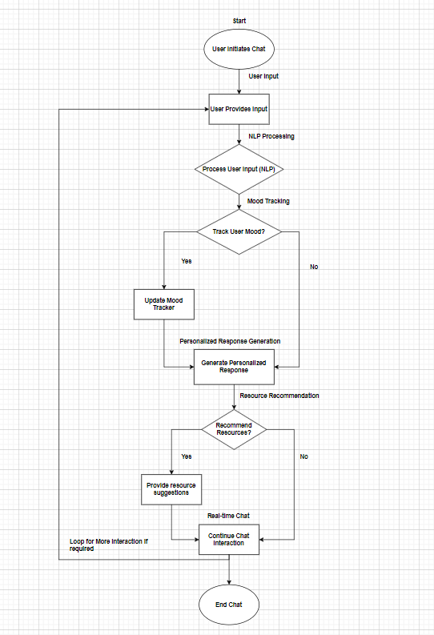

**Link to your updated Azure Boards:** [**Link to our updated Azure Boards**](https://dev.azure.com/PrithvirajuVenkataraman01/)

**Link to your GitHub repository:** [**Link to our GitHub repository**](https://github.com/IS-Team12/AI-Mental-Health-Chatbot.git)